Exercise 4: Arrange-Act-Assert (AAA) Pattern, Test Fixtures, Setup and Teardown Methods in JUnit

**Testing using the AAA pattern and** **using @Before and @After annotations for setup and teardown methods.**

import org.junit.After;  
import org.junit.Before;  
import org.junit.Test;  
import static org.junit.Assert.*;  
import org.example.Calculator;  
  
public class CalculatorTest {  
 private Calculator calculator;  
  
 @Before  
 public void setUp() {  
 // Arrange (setup)  
 calculator = new Calculator();  
 System.*out*.println("Setup: Calculator instance created");  
 }  
  
 @After  
 public void tearDown() {  
 // Teardown  
 System.*out*.println("Teardown: Test completed");  
 }  
  
 @Test  
 public void testAddition() {  
 // Arrange  
 int a = 5, b = 3;  
  
 // Act  
 int result = calculator.add(a, b);  
  
 // Assert  
 *assertEquals*(8, result);  
 }  
  
 @Test  
 public void testSubtraction() {  
 int result = calculator.subtract(10, 4);  
 *assertEquals*(6, result);  
 }  
  
 @Test  
 public void testMultiplication() {  
 int result = calculator.multiply(4, 3);  
 *assertEquals*(12, result);  
 }  
  
 @Test  
 public void testDivision() {  
 int result = calculator.divide(10, 2);  
 *assertEquals*(5, result);  
 }  
  
 @Test(expected = IllegalArgumentException.class)  
 public void testDivisionByZero() {  
 calculator.divide(10,0);  
 }

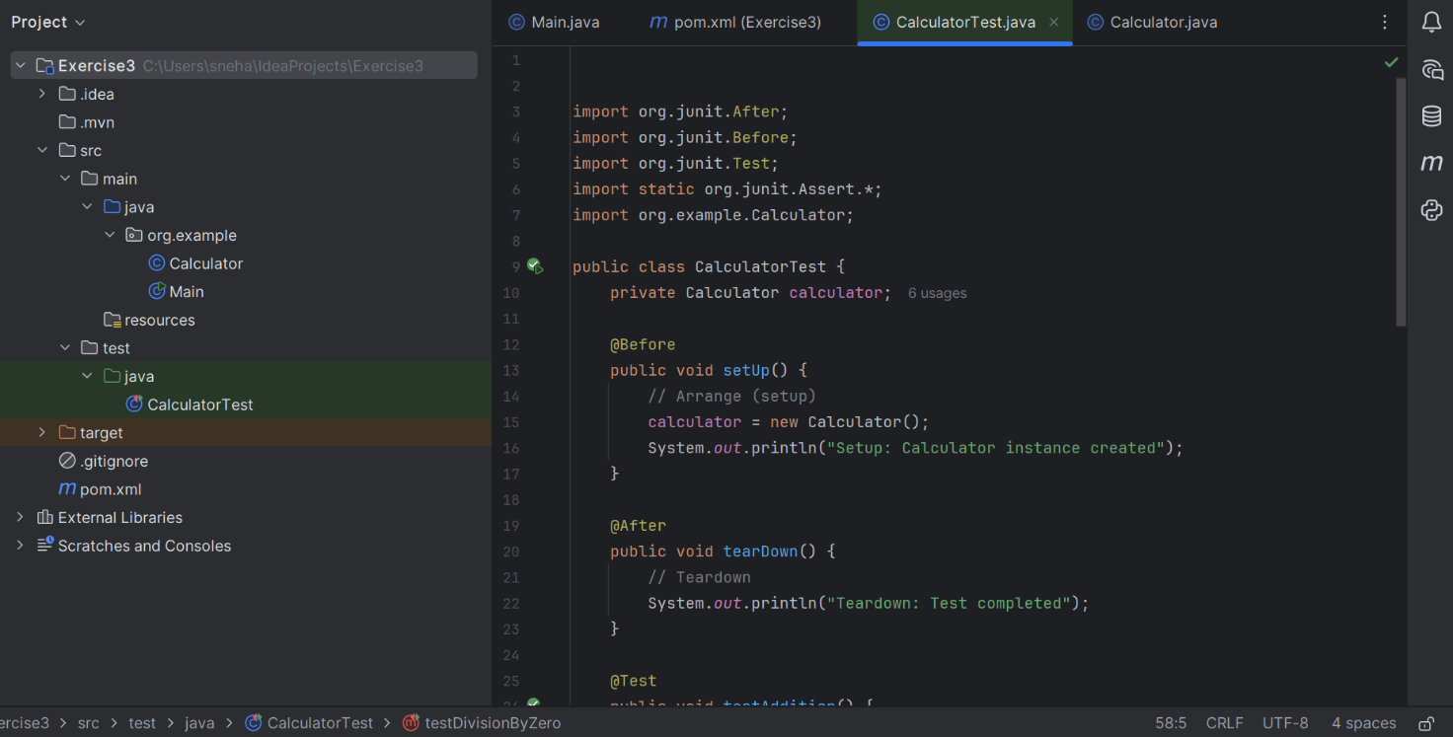

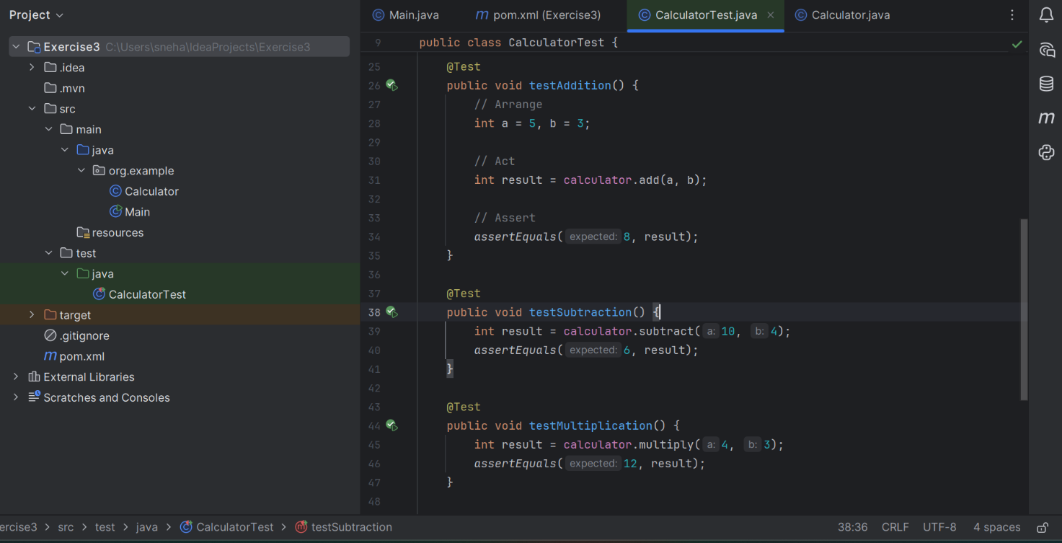

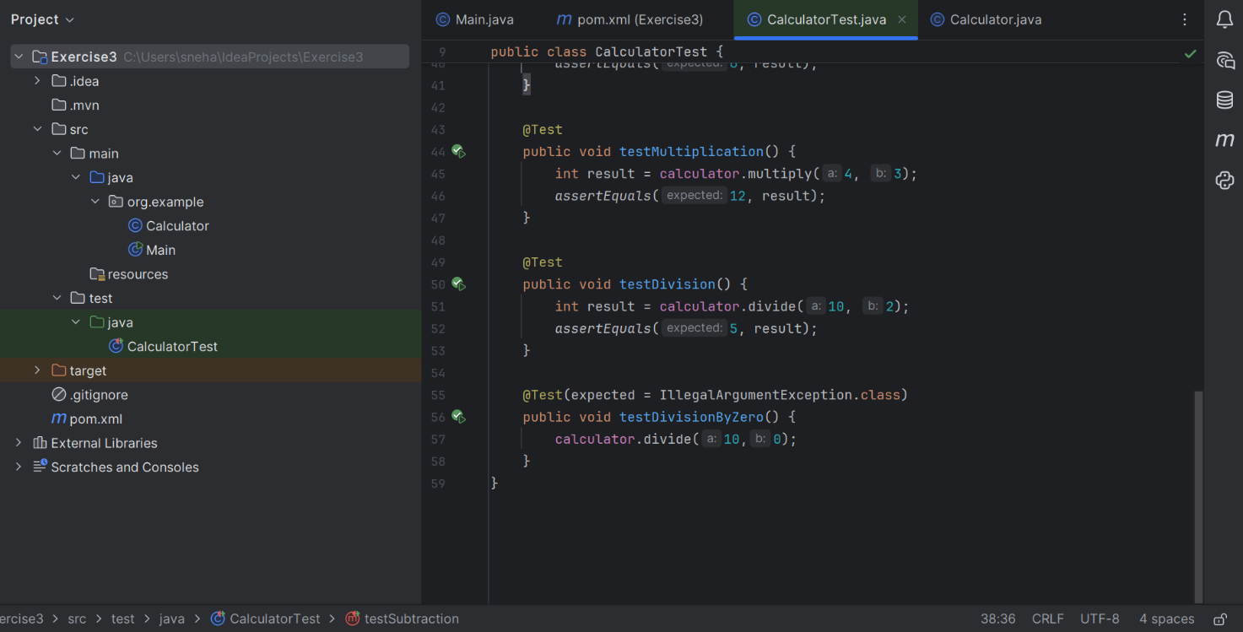

**OUTPUT:**

